Accessing Schoology Through your myBCPS Account
Parents/guardians that have a myBCPS account are provided access to Schoology, our learning management system, through BCPS One. Schoology is where you can find student courses, grades, assignments, and communicate with teachers.
Step One  Visit https://bcpsone.bcps.org and click “LOGIN to BCPS ONE.” | 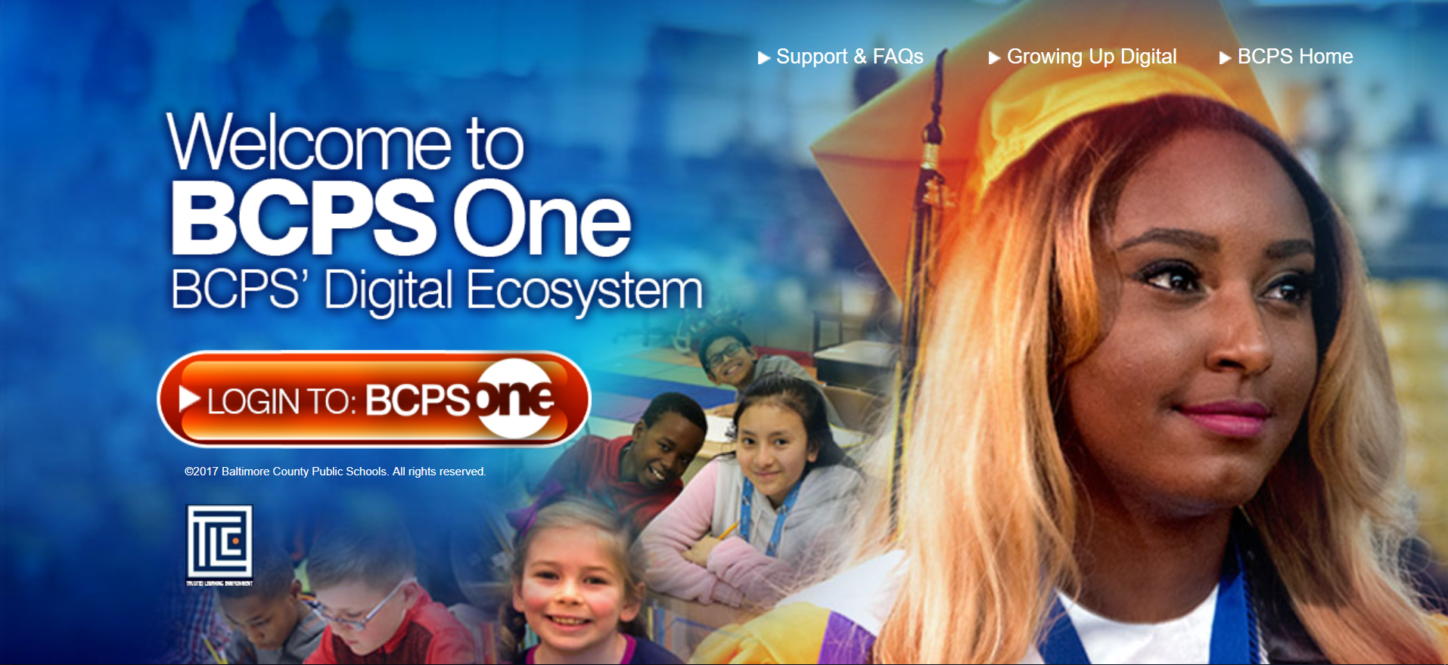
Step Two  Enter your username, password, and click “LOG IN.” | 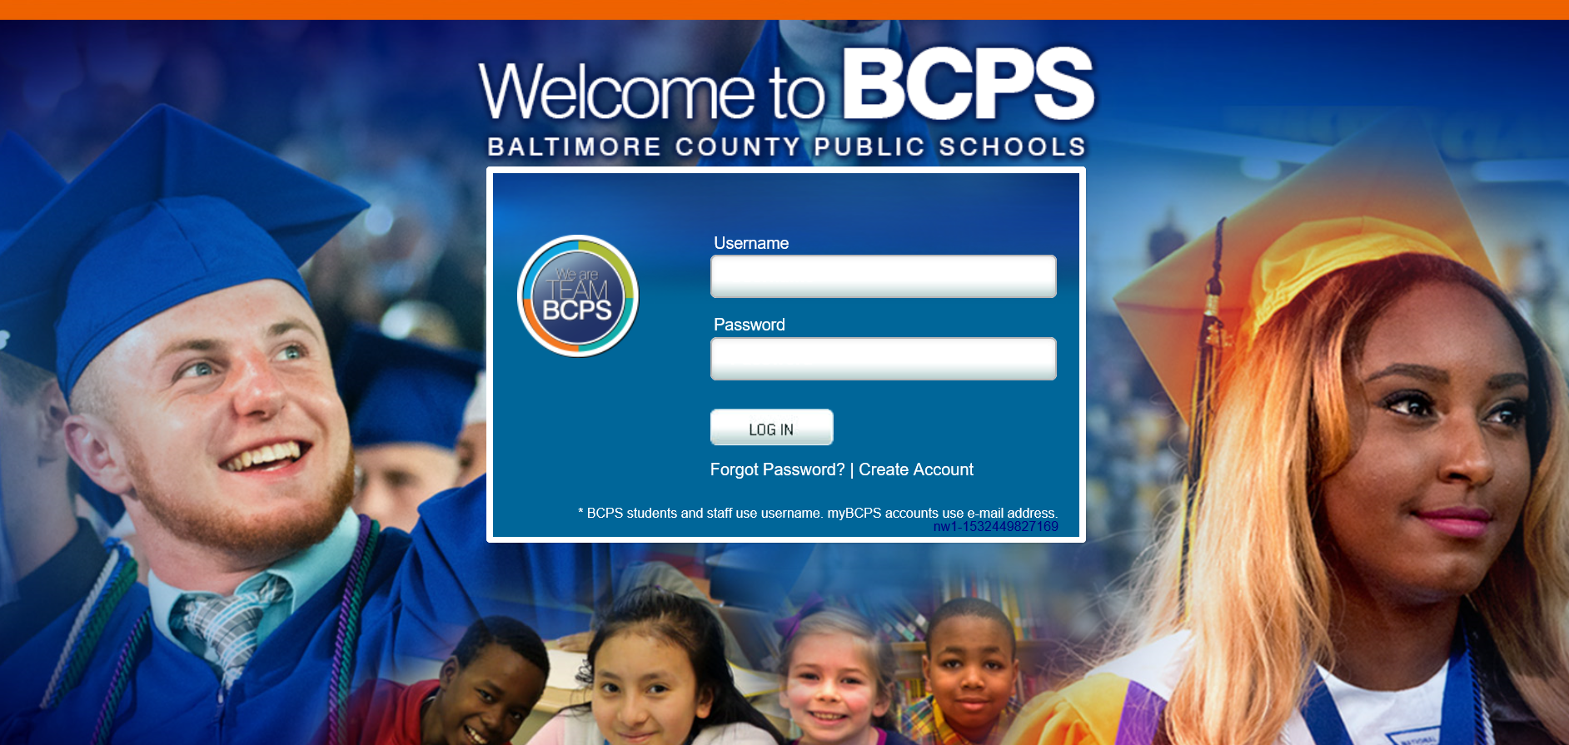
Step Three  Click the “Schoology Learning Management System” tile on the top left corner of the BCPS One splash page. | 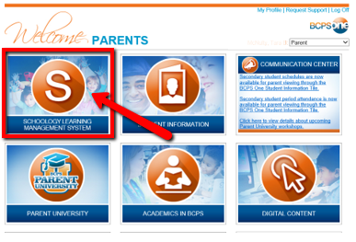
Step Four  You have successfully landed on your Schoology Parent View page! | 