Navigating the Student View in Schoology
As a parent/guardian you can view your student’s account activity.
View Student’s Account  The check mark in the drop-down menu indicates which account you are currently in.  The light blue bar at the top also indicates that you are currently viewing the page as your student. | 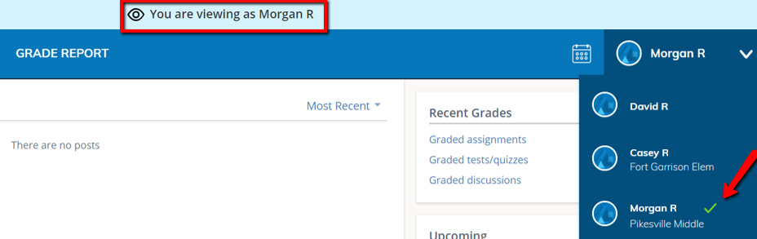
Student Activity View  Student Activity will allow you to see Schoology from your student’s perspective.  Here you will be able to view your student’s Courses, Groups, Grade Report, Student Activity, Most Recent Activity, Recent Grades such as assignments, test/quiz activities, discussions, and Upcoming assignments or events. | 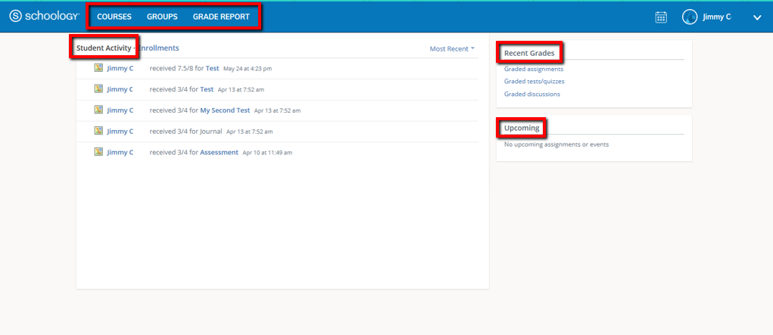
Enrollments  Enrollments allows you to see the Courses and Groups that your student is enrolled in, as well as current grades for the Courses. | 