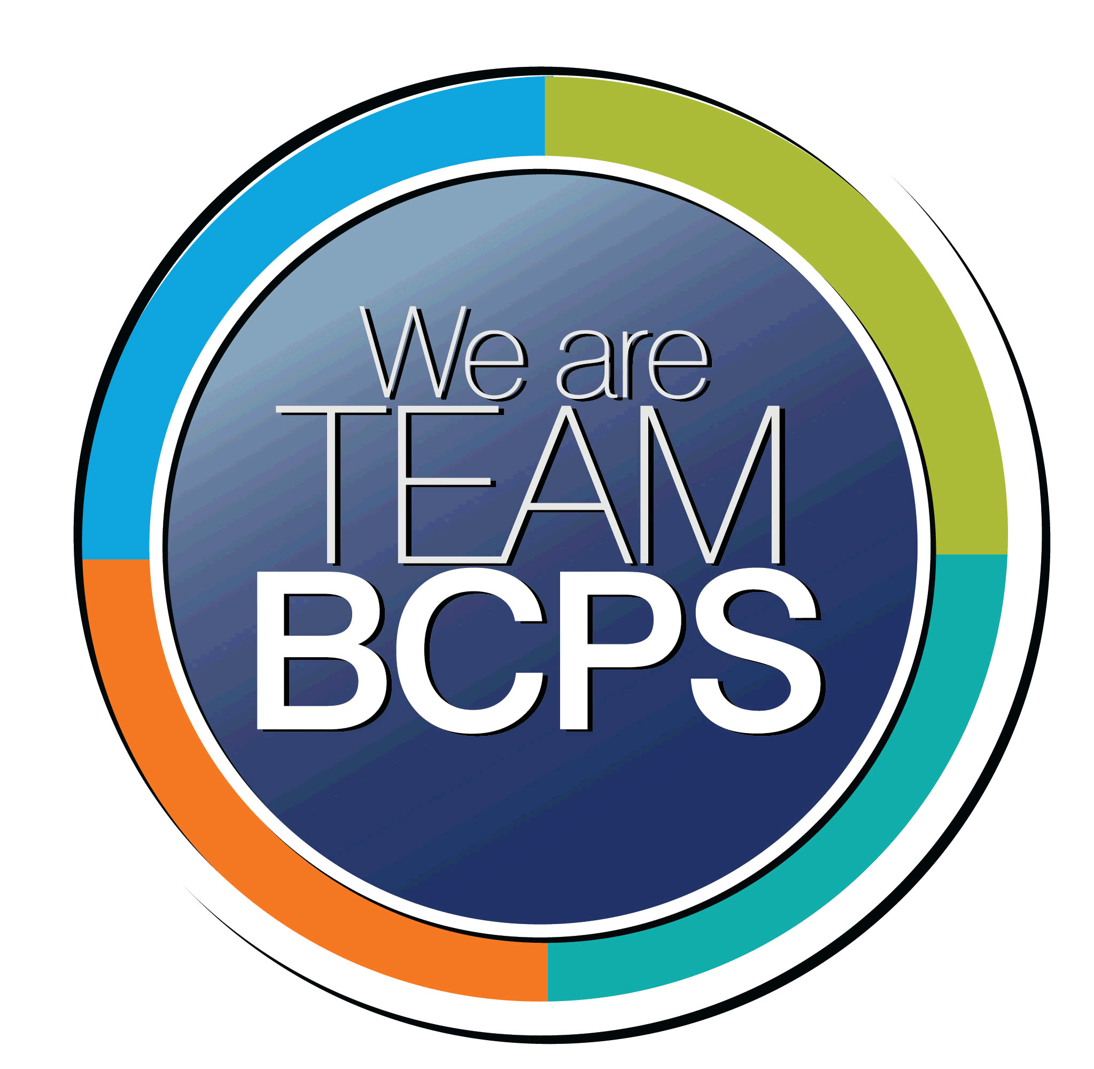 Schoolwide Positive Behavior Plan 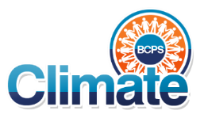
Baltimore County Public Schools

Date Completed: 8/6/2021 School Year 2021-2022
School: 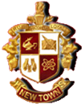New Town High School

Section 1: Initial Steps
School Climate Team
Identify members of a School Climate Team (consider a representative selection of members). The team meets initially to examine equity concerns and data and to develop the Schoolwide Positive Behavior Plan. The team should then meet monthly (minimum quarterly) to assess the effectiveness of the SWPBP on an ongoing basis.
School Climate Team
Principal James Martin
Mr. Johnson
Mr. Kopec
Mr. Soler
Ms. Christian
Dr. Wood
Ms. Muller
Ms. DaCosta
Equity Lens
Through an equity lens, identify what the data indicate about the social-emotional needs of students and the support provided by staff members relative to disproportionality between student groups, especially for African Americans or students receiving special education. Also consider the school’s population with regard to ELL, Latinx, and/or other student groups. (Information may be from School Data Story)
At NTHS, our Grades 9-12 2021-2022 Aug. 3rd enrollment indicates that we have 1168 students, and our demographics are as follows: 91.35% Black/African American, 1.88% White, 2.82% Hispanic, 3.17% Two or More Races, 0.94% Asian. The proportion of students eligible for receipt of special services are as follows: 16.2%
The diverse population of students at NTHS is a strength. As the positive behavior plan develops, we will look at all our data with an equity lens.
-Engage in reflective, honest, authentic, and courageous conversations about staff and student diversity.
• Examine learned cultural beliefs, experiences, and recurrent processes that can create biases, often implicit bias, toward students.
• Review school-level data for disparities, patterns, and themes among student groups (e.g., race, gender, disability, etc.).
• Analyze the data to determine what practices are advantaging some students and disadvantaging marginalized students.
• Develop a plan to interrupt those practices
Data Analysis
Summarize what the data tell about the school climate. (Information from School Data Story)
At NTHS, our Grades 9-12 2021-2022 Aug. 3rd enrollment indicates that we have 1168 students, and our demographics are as follows: 91.35% Black/African American, 1.88% White, 2.82% Hispanic, 3.17% Two or More Races, 0.94% Asian. The proportion of students eligible for receipt of special services are as follows: 16.2%
Suspensions – See New Town High School Data Story
-Our Black/African American students are suspended at rates higher than their non-Black / African American Peers
- Students eligible for Special Education are suspended at rates higher than their non- Special Education peers.
Graduation Rate – 93.31%
- Students eligible for Special Education graduate at rates lower than their non-Special Education peers. This gap has narrowed over time and is a positive trend but should still be a focus of our work.
Dropout Rate- 3%

Climate Goals
Identify the school’s goals in improving the social-emotional climate of the building. (Information from School Progress Plan)
-During the 2021-2022 school year, there will be a 5% reduction in reoccurrences for incidents resulting in suspension.
-Educators will examine and interrogate their personal biases to become aware of the ways in which their own cultural experiences influence the conditions and learning opportunities that they create for students.

Section 2: Developing and Teaching Expectations
Expectations Defined
Identify a School Code of Conduct with 3-5 positively stated school expectations. Develop a way to communicate the identified rules, based on the schoolwide expectations, for specific settings within the school building. Expectations should be clearly stated, communicated, taught, and frequently referenced.

Titan Up!!!
A: Attend
A: Achieve
A: Accelerate
Classroom Plan for Teaching and Reinforcing Expectations, Routines, and Procedures
Teachers develop visuals to communicate culturally relevant classroom expectations, routines, and procedures based upon the schoolwide expectations. Educators explicitly teach expectations, routines, and procedures. The school staff recognize and reinforce expected and positive behavior. Teachers identify encouraging procedures and corrective procedures for their classrooms.
Teachers will be supplied visuals which will acknowledge prosocial behaviors Teachers can utilize the visuals to reinforce prosocial behaviors that are seen in their classroom on a regular basis. PBIS, IB and SEL staff will offer virtues program presentation schoolwide via announcements that will be presented to the school prior to October 1st and monthly.
Family/Community Engagement
Identify how the Schoolwide Positive Behavior Plan, the schoolwide expectations, and/or interventions will be communicated and shared with families. Consider how to include family and student voice in the initial plan and in evaluating the plan throughout the year.
School wide positive behavior plan and school wide expectations will be shared in the monthly newsletter. Interventions like our Titan UP Check and Connect will be communicated with families and the community.
Other school wide initiatives include:
-Check and Connect and QR code posted around the building for students and families to access to share concerns
-Positive Post Cards Home to families
-Survey Community for unput
-Students of the Month
-Mentoring based on staff referral and ALC, referral and suspension data

Section 3: Developing Interventions and Supporting Students
Resource Mapping of MTSS
Identify the evidence-based practices and interventions offered at Tier 1, Tier 2, and Tier 3 to support all students. Consider what culturally responsive interventions the school requires to meet the specific needs of the students.
-Check and Connect Survey: Tier 1
-Monthly Virtues: Tier 1
-Survey Community for input: Tier 1
-Counselor Check ins: Tier 1
-Monthly Project Graduation Meetings: Tier 1
-Students of the month: Tier 2
-Scholar of month: Tier 2
-Mentoring: Tier 3
-Daily announcements that include Titan TV daily: Tier 1

Social-Emotional Learning
Identify the specific evidence-based social-emotional learning skill development practices the school will implement during the school year. Consider the importance of trauma-informed care, mental health awareness, level of students’ coping skills, etc. Determine how the social-emotional learning and the SEL competencies will be integrated into the school’s programming. Consider the need for any training the staff members may require.
-PBIS/SEL will present in August prior to start of school year and each month at staff PD and faculty meetings.
-SEL squad included to provide interventions for suspensions, mediations, physical and verbal altercations

Character Education
Determine how specific evidence-based character education learning will be infused into the school’s programming to promote positive behavior and ethical decision-making. Character education will be culturally responsive and co-created with diverse stakeholders. Consider the need for any training the staff members may require.
Mentoring Program- This program will allow a group of targeted individuals have access to a mentor and regular activities that engage students in Mentors. The focus of the program will be to build strong relationships and offer life lessons and skills to the group.

Professional Development for Staff
Identify the professional development that will be offered to staff members throughout the year in order to support their knowledge, skill development, and implementation of the interventions selected, the character education learning, and social-emotional learning practices. Specify the schedule for professional development and how to obtain teacher feedback during the year to address their concerns and areas in which they want/need more information. (Information from School Progress Plan.)
PBIS will present in August prior to start of school year and each month at staff PD and faculty meetings

Section 4: Supporting and Responding to Student Behavior
Recognitions/Incentives
Identify a variety of positive consequences, acknowledgements, recognitions, and/or incentives that are linked to the behavioral expectations and rules. Develop a system for implementing the positive acknowledgements consistently in school settings. Consider how to monitor who is being recognized and who is not being recognized and whether explicit or implicit biases may be occurring.
New Town High School will have an incentive program for students each month. “Titan UP Incentives” 2 students for 9 through 12 grades, classes also will select 2 scholars each grade, 10 total. (Months of incentives, September through May)

Hierarchy for Behavioral Referrals and Consequences
Identify the behaviors that are teacher-managed, behaviors referred to resource staff, and behaviors referred to administration. Refer to the BCPS Student Handbook for teacher and administrator-led interventions. Consider how unsafe behaviors will be addressed.
Teacher Managed

Inappropriate Verbal Language
- Non-directed profanity
Physical
- Pushing, shoving unsafe rough play
- Teasing/ put downs
- Running in building
Defiance/Disrespect/Non-compliance
- Out of assigned seat/area
- Inappropriate statement to peer
- Failure to follow classroom rules
- Chewing gum or eating
- Non-directed spitting
- Littering
- Uncooperative behaviors
- Silly behaviors
- Cheating
- Dress code violations
Disruption
- Calling out
- Throwing objects
- Late to class
Property Misuse
- Writing on desk/books
- Cell phone/iPod usage
- Skipping/ truancy
Department Managed

Category I Events
- Fighting/Physical Aggression Level I-hit slap, kick, forceful push that resulted in a fall
- Abusive/Inappropriate Language
- Defiance/Disrespect
- Non-Compliance
- Cheating
- Harassment/tease/taunt
- Disruption
- Tardiness
- Dress Code Violation
- Skipping/truancy
- Forgery/theft (level I)
- Telecommunications violation (level I- cell phone, iPod)
- Property misuse / damage (minor)

Administrator Managed
- Chronic Category I Events *
- Gross disrespect to staff
- Fighting/physical Aggression- Level II
- Property Damage (major)
- Vandalism
- Theft – Level II
- Use/possession of tobacco, alcohol, drugs, combustible items
- Bomb threat/ false fire alarm
- Arson
- Weapon
- Written or verbal statements that are sexual in nature/gesture
- Telecommunication violations- Level II –cyber bullying / Harassment
- Category III Events

*Chronic – continued violation after repeated/documented teacher and department interventions

Response for Intensive Behaviors
Identify a hierarchy of responses to intensive behaviors (i.e., emergency/crisis management/threat assessment/unsafe behaviors) including interventions and supports. Indicate which school staff members will respond as well as procedures and training as needed.
-SEL squad included to provide interventions for suspensions, mediations, physical and verbal altercations
-ALC prior to suspension
-ALC time to include processing of the incident and ways to avoid in the future
-Arrange meeting(s) with school counselor, administrator, mentor, trusted adult
-Assign mentor based upon staff recommendations and suspension, referral, ALC data
-Mentees will be selected by staff to assure relationship is as positively impactful as possible
-Threat assessments to be conducted immediately following threats of harm to self or others
-Admin training on reinstatements and mediation procedure
-Staff training on use of regroup and rejoin pass/online, when and how to communicate emergencies, when to submit office referral, proactive classroom interventions to avoid escalation
-Signs around the building with QR code for regroup and rejoin online link for students and families to communicate concerns

Monitoring the Schoolwide Positive Behavior Plan/Data Analysis
Identify the data that will be collected and reviewed by the School Climate Team in order to identify behavior trends, patterns, action steps, and interventions using a problem-solving strategy. Consider having a uniform referral form for staff to complete to document referrals to administration. Consider how teachers should document classroom-managed concerns/behaviors/difficulties. (Information from School Progress Plan.)
New Town High School has adopted the Titan UP check & connect spreadsheet and Gift incentive program to keep up with our data analysis. This data will come with a school Positive behavior plan using School resources like Excel, Forms and Class Dojo etc... We are also working close with our IB program and other school groups for input.
The PBIS, SEL, CLS and IB will review the following data at the monthly meetings.
Suspensions- This data will be pulled monthly by Mr. Soler.
Check and Connect Data – This information can be shared with team from students based on QR scan spreadsheet Mr. Johnson.
Referral Data- This data will be pulled monthly by Mr. Soler
Positive Post Cards Home- Teachers will submit names of positive post cards to PBIS team.
NTHS Staff Titan UP- This data will be reviewed during interims and end of quarter by Mr. Martin and Mr. Kopec.
Students of the Month -This information will be shared with Administration monthly by teachers Ms. Muller and Mr. Johnson.
Scholar of the Month- This information will be shared with Administration monthly by teachers Mr. Martin and Mr. Johnson.

Section 5: Miscellaneous Content/Components
NTHS Titan UP Check and Connect Scan Barcode

